**WEST WARWICKSHIRE SPORTS CLUB**

**COVID-19 – RE-OPENING OF**

**THE SQUASH COURTS**

**DURING SOCIAL DISTANCING**

**Squash Section Returning to Restricted Play**

Version Draft 0.2 - 20th July 2020

Contents

1 Introduction 1

2 Before you consider playing 1

3 Risk Assessment 2

4 Procedure 2

4.1 Booking and Arrival 2

4.2 At the courts 3

5 Ways to play 4

5.1 “Sides” 5

6 Accidents and Emergencies 5

7 Club Precautions 5

8 Updates 5

9 England Squash Posters 7

# Introduction

These guidelines are written specifically for West Warwickshire Sports Club, they include guidance provided by the NHS, the Government (BEIS & DCMS) and England Squash[1]. This procedure cannot be implemented until the UK Government guidance allows indoor sports, currently scheduled for the 25th of July. The procedure protects the participants, staff and others at the club, to play squash at the club these procedures must be followed.

The virus is transmitted in saliva and nasal fluid, either directly as airborne droplets or from surfaces, entering the body through the mucus membranes of the mouth, nose and eyes. You can’t get it from sweat, however, heavy breathing increases the exposure from an infected person. Due to the nature of the game, squash, along with basketball, volleyball and boxing is considered to have a high risk, all are indoors, hard work and require close contact in normal play.

# Before you consider playing

Follow all other current guidance, do not go out if you, or anyone in your household have symptoms of COVID-19, or if you have been told to self-isolate through the contact tracing system, test and trace.

According to NHS.uk, 20/05/20, symptoms are:

* **high temperature** – this means you feel hot to touch on your chest or back (you do not need to measure your temperature)
* **new, continuous cough** – this means coughing a lot for more than an hour, or 3 or more coughing episodes in 24 hours (if you usually have a cough, it may be worse than usual)
* **loss or change to your sense of smell or taste** – this means you've noticed you cannot smell or taste anything, or things smell or taste different to normal

Most people with coronavirus have at least one of these symptoms.

To help trace any possible contacts, if you have been to the club and subsequently become ill or are tested positive for COVID-19 you must let the club know, the booking system will be used to inform others that may have been affected.

# Risk Assessment

A risk assessment is a legal requirement for a place of work like the Club.

Before attending to play squash, you must acknowledge understanding of this document and declare that, to the best of your knowledge you nor anyone in your household have COVID-19. If you have had or suspect that you have had COVID-19, you must observe the current isolation periods and should consider taking medical advice before returning to squash.

The hazard is the COVID-19 virus, the risk is the likelihood catching or transmitting it. The longer you are exposed to the virus the more likely you are to catch it, walking past someone outside has a much lower risk than talking face to face.

To reduce the risk of transmission and/or contraction of COVID-19, we have to reduce the likelihood of bringing it to the club, picking it up at the club or taking it out of the club.

There are five steps to safety

* Carry out a risk assessment – this document is the result of that assessment
* DO NOT leave home if you or anyone in your household have symptoms or have tested positive. Think about your own situation, if you are classed as clinically vulnerable you should consider not coming to the club.
* Ensure that cleaning, handwashing and hygiene procedures are stepped up in line with government guidance and maximise the ventilation in the squash block.
* Maintain 2 m distance as much as possible.
* Where 2 m distance is not practical, manage the transmission risk by limiting the expose of face to face time.

# Procedure

## Booking and Arrival

* All of the usual membership requirements continue to apply, check the club website for changes to opening times.
* All courts must be pre-booked using the on-line system or by telephone to the club, the screen in reception can’t be used. One or more of the courts may be out of use depending on a review when we start playing again.
* Toilets are available, however changing rooms and the showers are not available.
* You will need to bring antibacterial wipes and your own hand sanitiser.
* The water dispenser is not available and there are no cups, there is no bin, bring everything you need with you, take everything your brought home. Don’t share anything.
* There is a one-way system, come into the club through reception, stay 2 m back from the desk to book in, the doors to the corridor, into the courts and out of the back of the court will be open, avoid touching anything. There are arrows on the floor to help.
* Play will be allowed depending on the current guidance, solo, with someone from your own household, with a coach managing court movement. Group coaching, doubles and Kings games may be some time away.
* Don’t arrive at reception early, wait outside until you can come in and pass straight through to the squash corridor.
* Do not use the seating at the back of the courts for anything, the only thing that should be touched is the door handle to the court when you close it to start play, and then to open it when it’s time to leave. The same person must do both the opening and closing.

## At the courts

* Enter the squash block and, if necessary, wait until the last users have left and the out of court area is clear.
* Sanitise your hands, enter the court and close the door using an antibacterial wipe. If you are playing with someone outside your household or support bubble, choose which one will handle the ball and open and close the door
* Consider the whole court and the ball as contaminated, **do not** wipe your hands on the walls or the floor, **do not** touch your face, take a towel or sweatband if you need to.
* Take a drink on court in a closed sports bottle, labelled with your name and leave it to one side of the tin.
* Take your bag on court
* Enjoy your game observing the current restrictions on play. Play and train within your limits to minimise the risk of any injury requiring hospital treatment. See section 5 below.
* Allow time to leave the building 2 minutes before your session is due to end.
* Use your antibacterial wipe to exit the court, leave the door open, sanitise your hands and observing social distancing, leave the building through the back-door fire escape 2 minutes before your time is up.
* Shower and wash your kit at home as soon as you can.

# Ways to play

The following guidance is provided by England Squash:

| **Who** | **Activities allowed** | **Considerations** |
| --- | --- | --- |
|
| Members from the same household or *support bubble* | Match play/full squash game (indoors) | Hand and touch point hygiene before and after playing. |
|
| Coach led/supervised activity (indoors or outdoors) | Hand and touch point hygiene before and after playing. |
| Only the coach to touch the ball and court door. |
| Social distancing between coach and members. |
| Individuals | Single player (solo) practices (indoors) | Hand and touch point hygiene before and after playing. |
|
| Coach led/supervised activity (indoors or outdoors) | Hand and touch point hygiene before and after playing. |
| Only the coach to touch the ball and court door. Social distancing between coach and player |
| Two members from different households (not in a *support bubble*) | Modified version of squash (indoors) – ‘Sides’ (see below) | Hand and touch point hygiene before and after playing. |
| Only one player touching the ball and court door. |
| Social distancing between both members. |
| Coach led/supervised activity (indoors or outdoors) | Hand and touch point hygiene before and after playing. |
| Only the coach to touch the ball and court door. |
| Social distancing between coach and members. |
| Up to **five** members from different households | Coach led/supervised activities (indoors or outdoors) | Hand and touch point hygiene before and after playing. |
| Only the coach to touch the ball and court door. |
| Social distancing between all members and coach. |

## “Sides”

This describes any game that requires players to stay on one side of the court. There is a helpful video on the England Squash Website.

<https://www.englandsquash.com/backtosquash>.

* Wash or sanitise your hands before starting.
* Take all your equipment on court, think about using a smaller bag and travelling light.
* The same person serves throughout the match, use the service only to get the ball in play, not to gain an advantage, no points can be won off the serve or service return.
* Change sides as while maintaining social distance, only one player touches the ball (and the door handle).
* If a player would need to change sides to play a ball, it’s a let, if the ball doesn’t cross the centre line the point is lost, any length is allowed.
* Don’t touch any surface, close the door with an antibacterial wipe, wash or sanitise your hands when you’ve finished.
* Leave the out of court area immediately and follow the arrows to leave the club.

# Accidents and Emergencies

If there is an accident, emergency treatment may override the need to maintain social distancing, judgement of the individual circumstances is required.

If the fire alarm sounds, leave the building as quickly as possible through the back door or through the corridor, do not re-enter the building until you are told it’s safe to do so. The assembly point is in the car park, there is enough space to maintain social distancing.

# Club Precautions

The following actions shall be taken to help reduce the risk.

* Appoint a COVID-19 Officer with an overview of the entire operation and risk assessments.
* Toilets and contact points, such as doors, including the court doors and surfaces will be cleaned on a more frequent basis.
* Use of face coverings where distancing is not practical
* Squash corridor windows and all internal doors to be left open as much as practical
* Squash extract fans to be run continuously while the courts are in use.
* Cover or remove the water dispenser, remove the bin and paper cups
* Install arrows and additional signs to help the flow through the building.
* Update booking times to allow phased change-over and time for cleaning.

# Updates

03/06/20 d0.1 Added detail from DCMS, PHE and reference to Test and Trace

20/07/20 1.0 Detail from England Squash added



# England Squash Posters

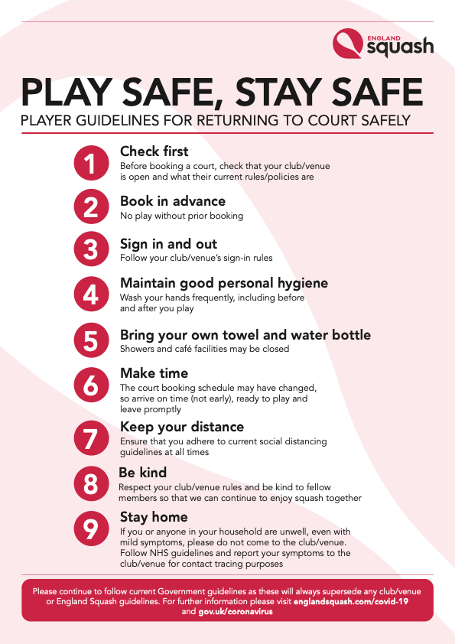

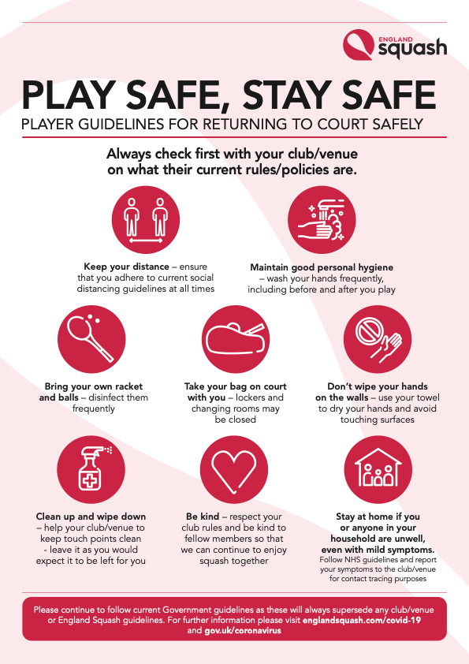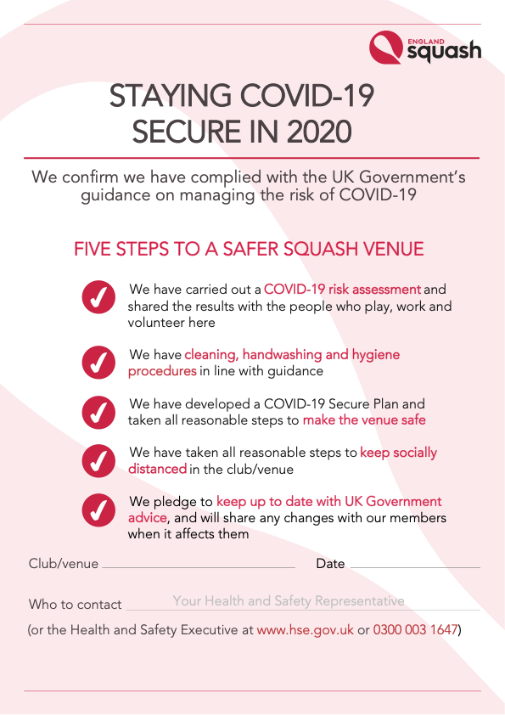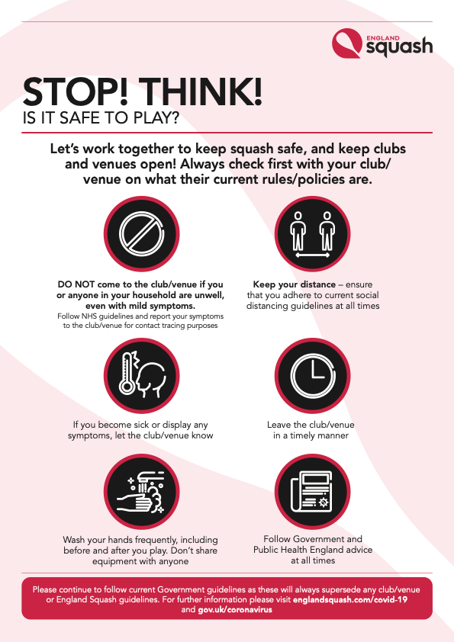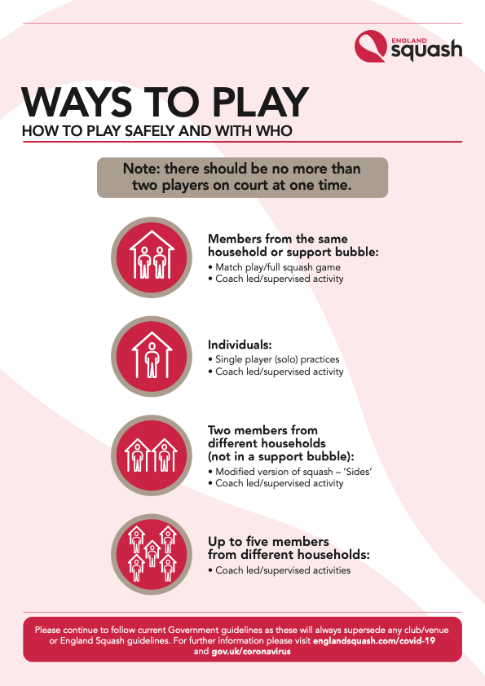

1. England Squash Back To Squash Guidelines v1 140720.pdf